**SRI MUTHUKUMARAN ARTS AND SCIENCE COLLEGE**

**(Affiliated to university of Madras)**

**CHIKKARAYAPURAM, CHENNAI - 600 069.**

**DEPARTMENT OF PHYSICS**

**Under scheme of**

**NAANMUDHALVAN**

**Project Title: SUBSCRIBERS GALORE: EXPLORING WORLD’S TOP YOUTUBE CHANNELS**

**Submitted By**

**PARTHIBAN M**

[**m.parthi.kcc.12345@gmail.com**](mailto:m.parthi.kcc.12345@gmail.com)

**PUNNIYAMOORTHI T**

[punniyamoorthi305@gmail.com](mailto:punniyamoorthi305@gmail.com)

**Team Id: NM2023TMID34829**

**Under the mentor of**

**Mrs.V.VANITHA**

**Assistant Professor**

vanithavelaiya82@gmail.com

**Department of Physics**

**1. INTRODUCTION**

Social media have not only changed how people communicate and interact with each other but also how media contents are presented and how recipients use these contents. A platform that has substantially changed the presentation and use of audio-visual content is the video-sharing website YouTube. A special feature that distinguishes videos on YouTube from traditional offline videos is that they typically are presented together with user-generated information about those videos. This information is presented in the form of views, (dis)likes, and comments. It forms an essential part of YouTube’s content because it informs viewers about the evaluations that videos receive by their audience. For example, video (dis)likes inform viewers about how positive or negative the overall audience of the video evaluated it. Therefore, we define this information as social information. Despite the prevalence of online social information on YouTube.

**1.1 Overview**

The idea of self-disclosure was first put forward by Jourard and Lasakow [5], who explained that self-disclosure means that oneself voluntarily discloses one’s own information or privacy to others and earnestly discusses with others one’s deepest thoughts, experiences, and process of experiencing. Derlega, Metts, Petronio, and Margulis [6] define self-disclosure as an exchange between two persons, one of whom discloses some personal information to the other with a purpose. Self-disclosure usually includes verbal information including statements such as “I feel” or “I think”, and the information also includes whether there is more private information, such as personal fears, religious beliefs held, etc. In addition to the critical impact of self-disclosure of everyday information in forming and maintaining a relationship with others, the use of information that an individual. YouTube is a video sharing service where users can watch, like, share, and comment and upload their own videos. The video service can be accessed on PCs, laptops, tablets and via mobile phones.

**1.2 Purpose**

The purpose of YouTube is to provide a platform where users can upload, share, and watch videos. The platform was founded in 2005 with the goal of making it easy for people to share videos with one another, and it has since become one of the most popular websites in the world.

**2. PROBLEM DEFINITION AND DESIGN THINKING**

**2.1 Empathy Map**

**Full Page Screen Shot**

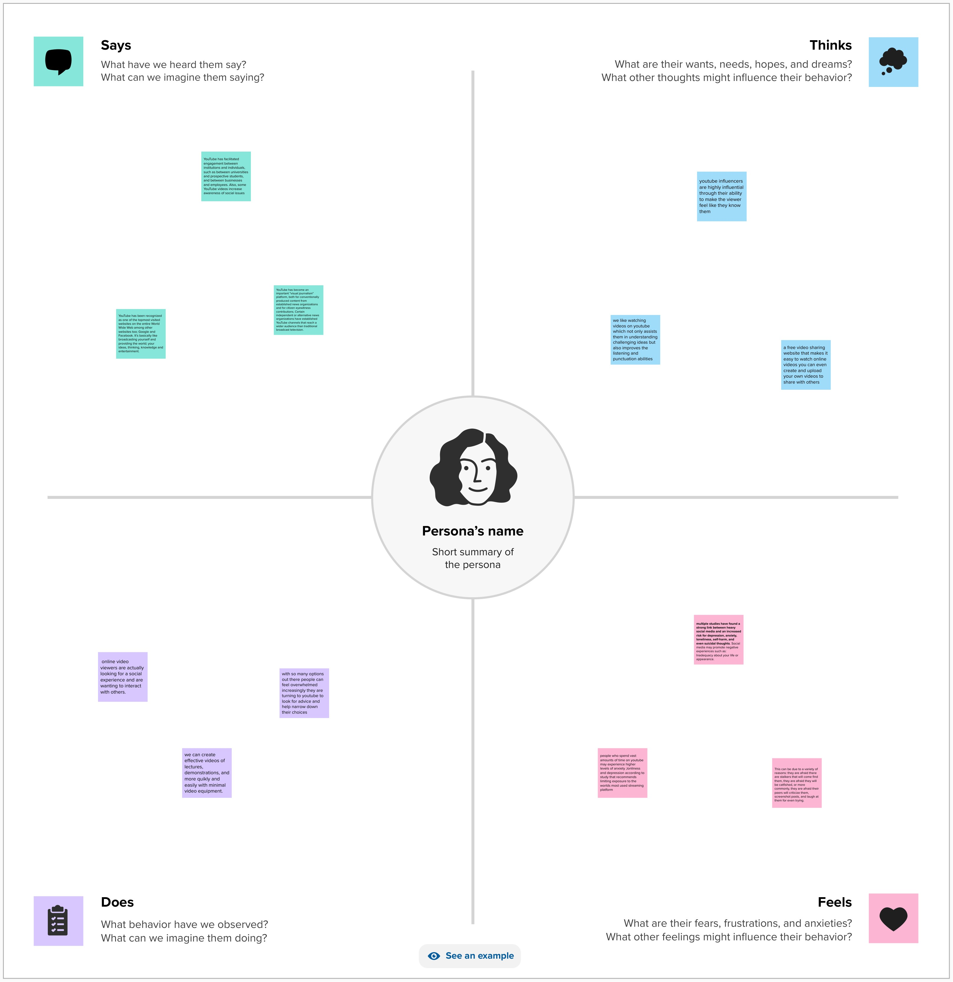

**2.2 Ideation and Brainstorming Map Screenshots**

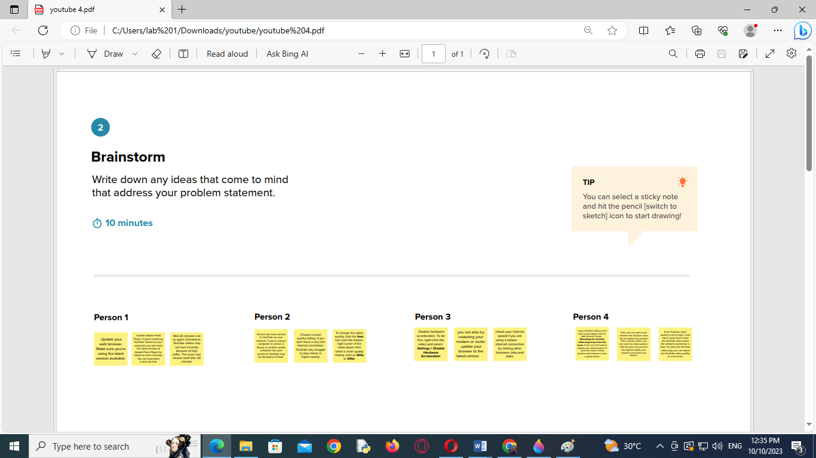

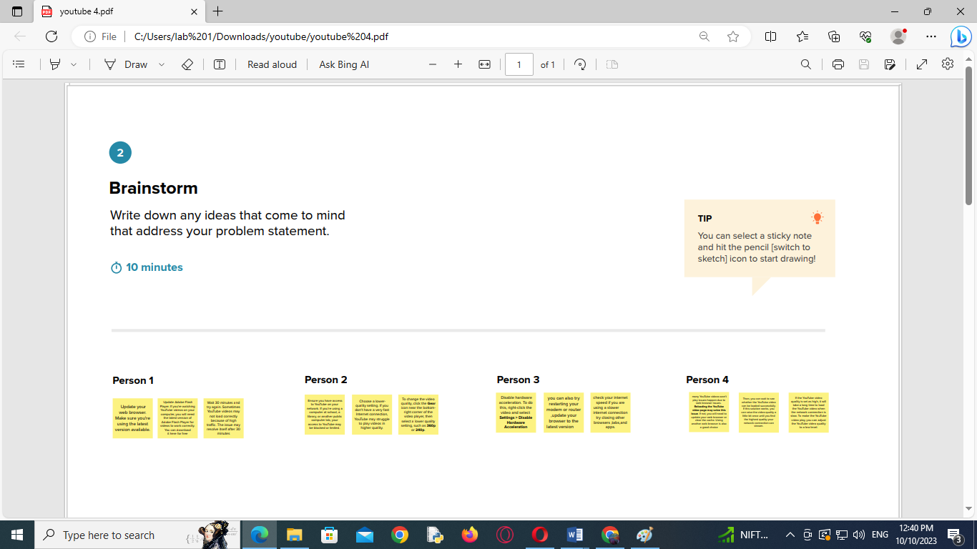

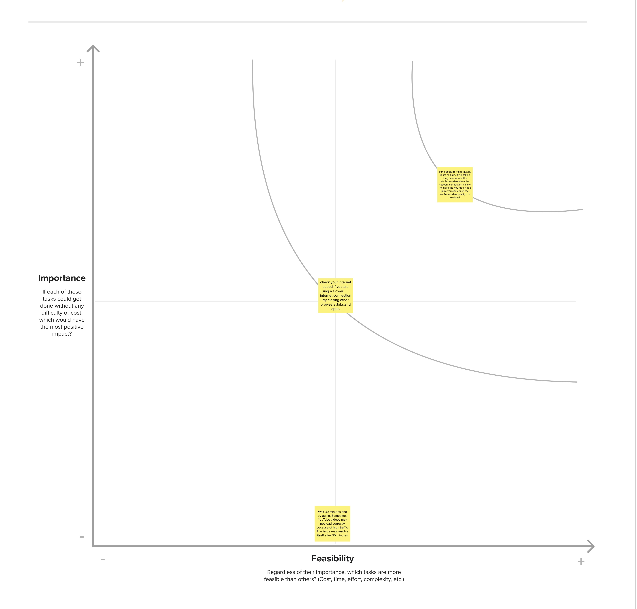

**3. Result**

Rank Wise Channel

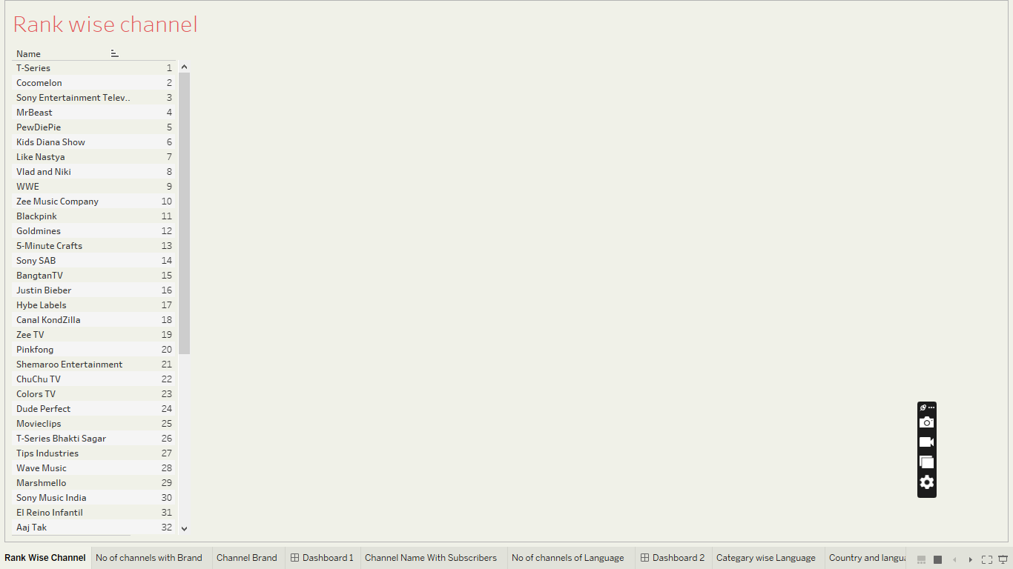

No of channels with Brand

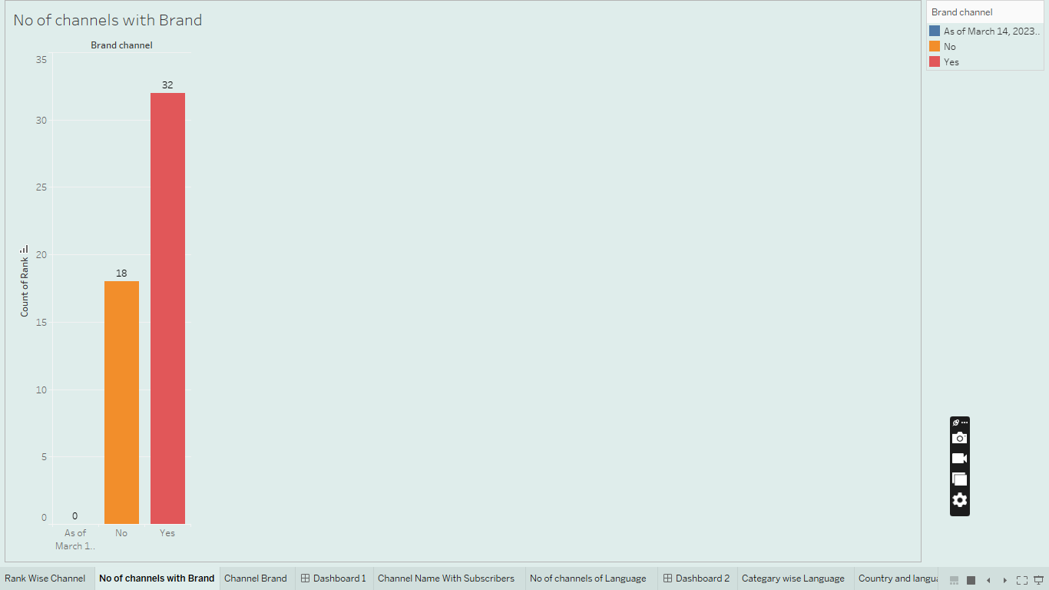

Channel Brand

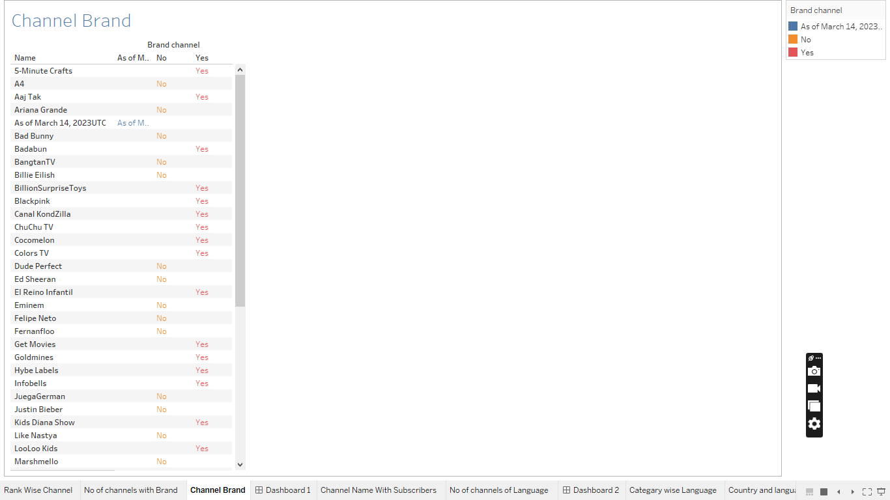

Dashboard 1

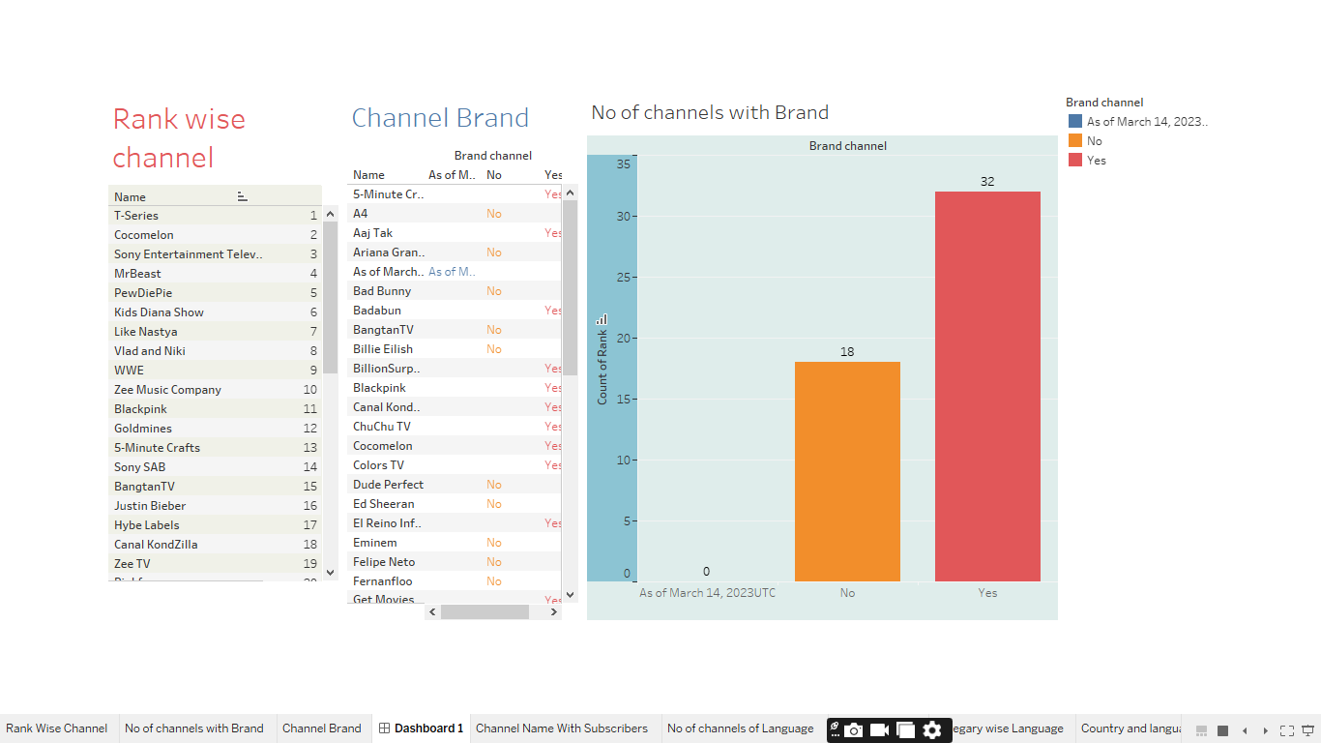

Channel Name with Subscribers

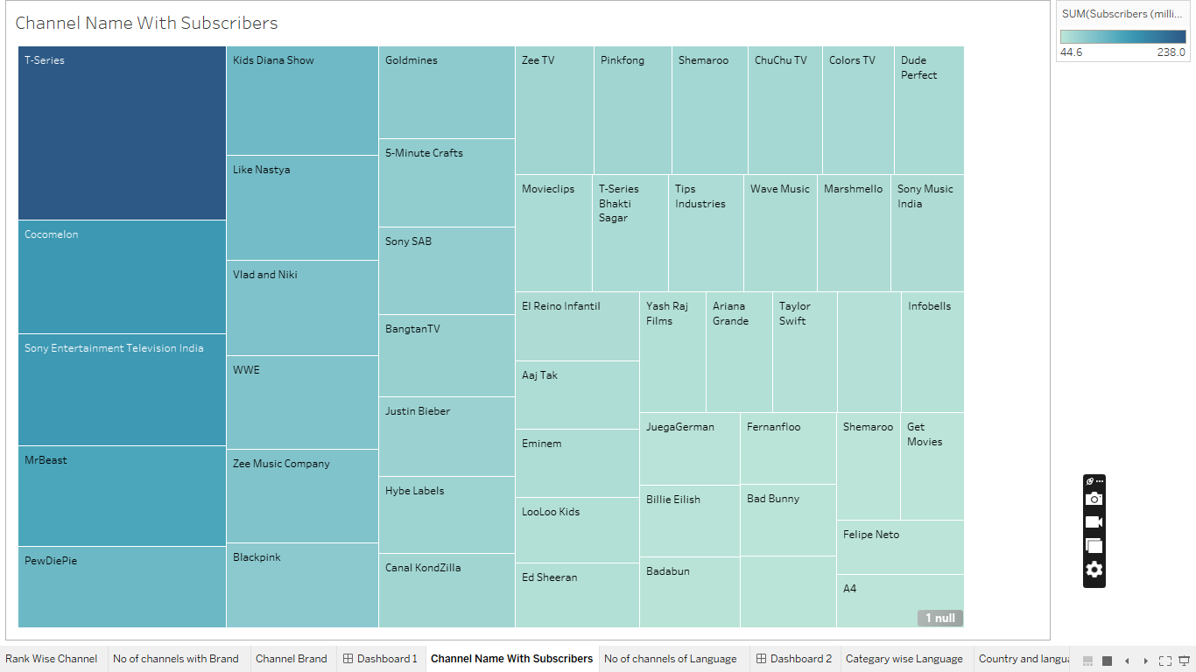

No of channels of Language

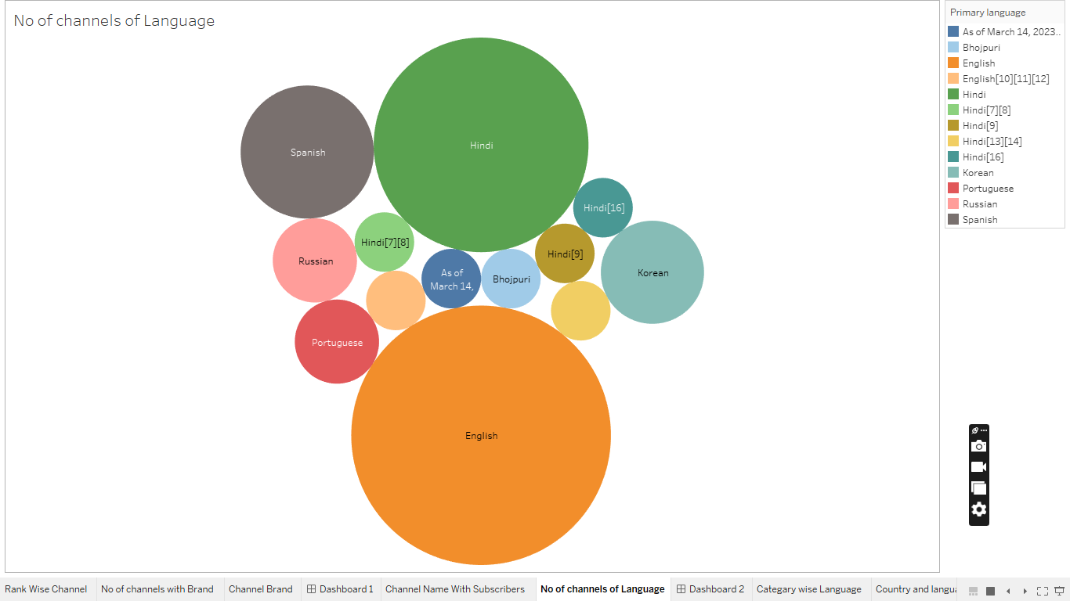

Dashboard 2

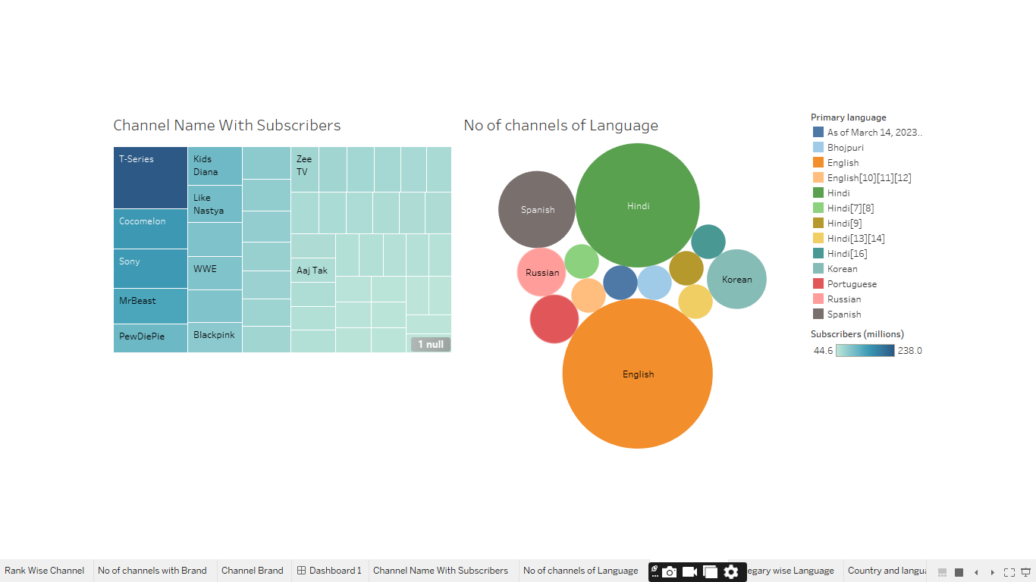

Category wise Language

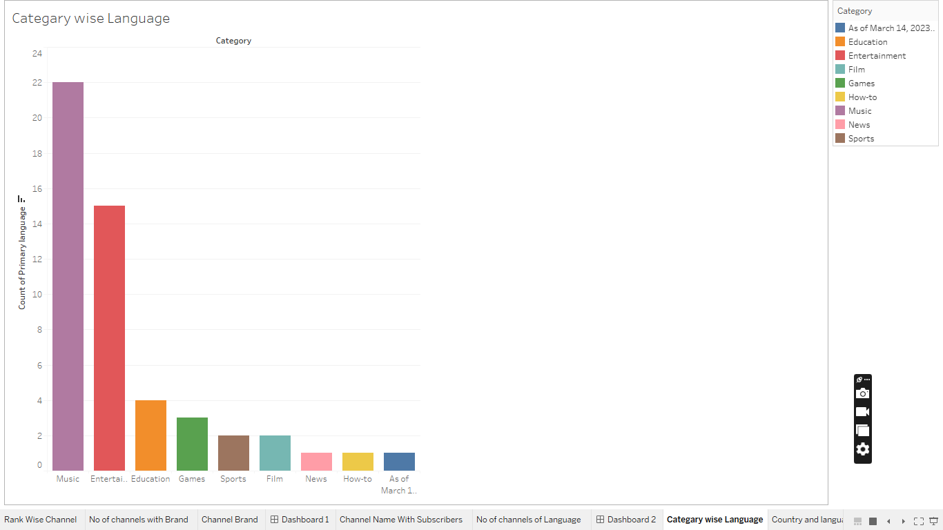

Country and Language

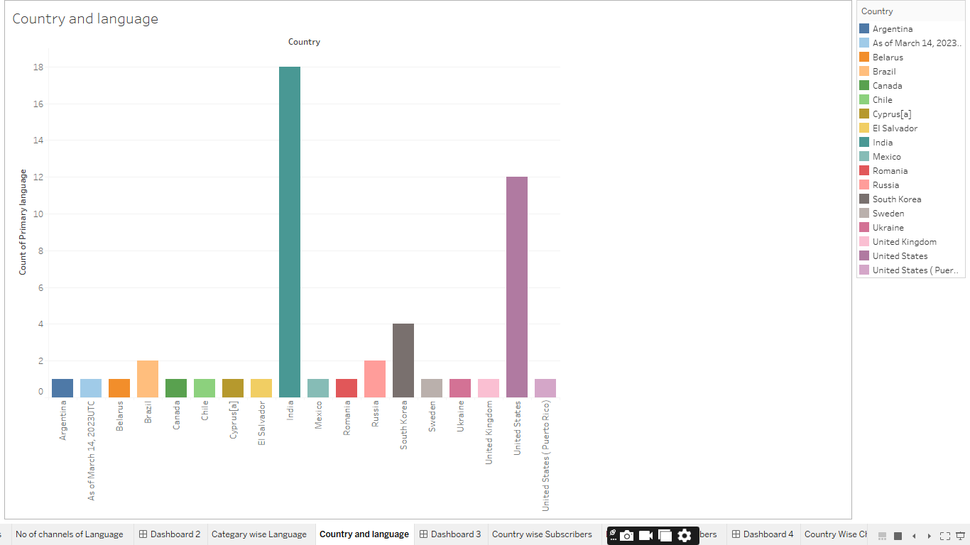

Dashboard 3

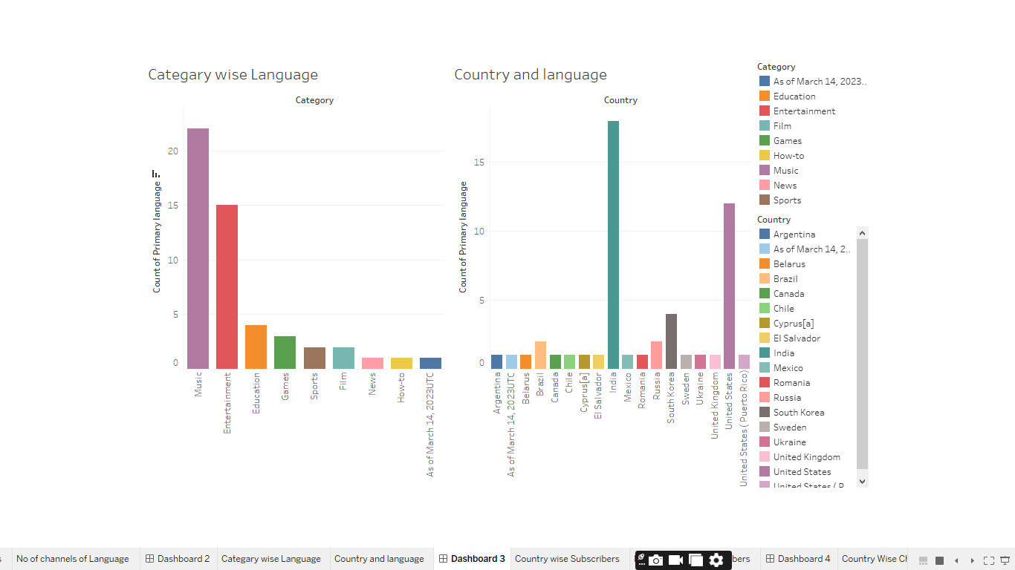

Country wise Subscribers

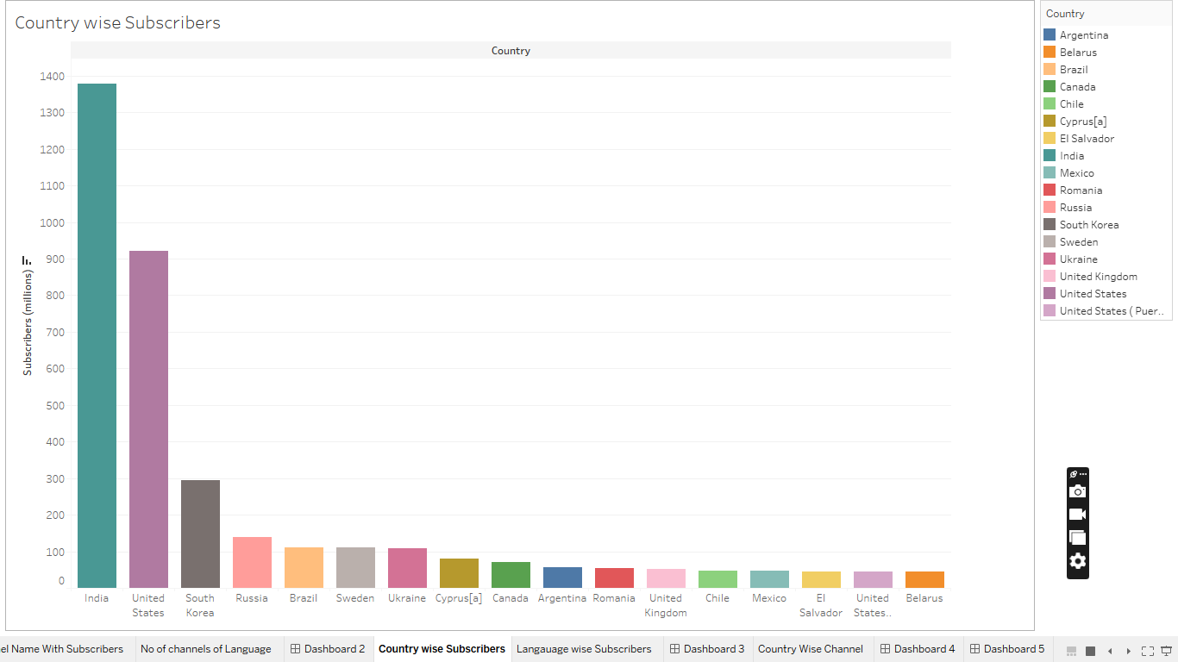

Language wise Subscribers

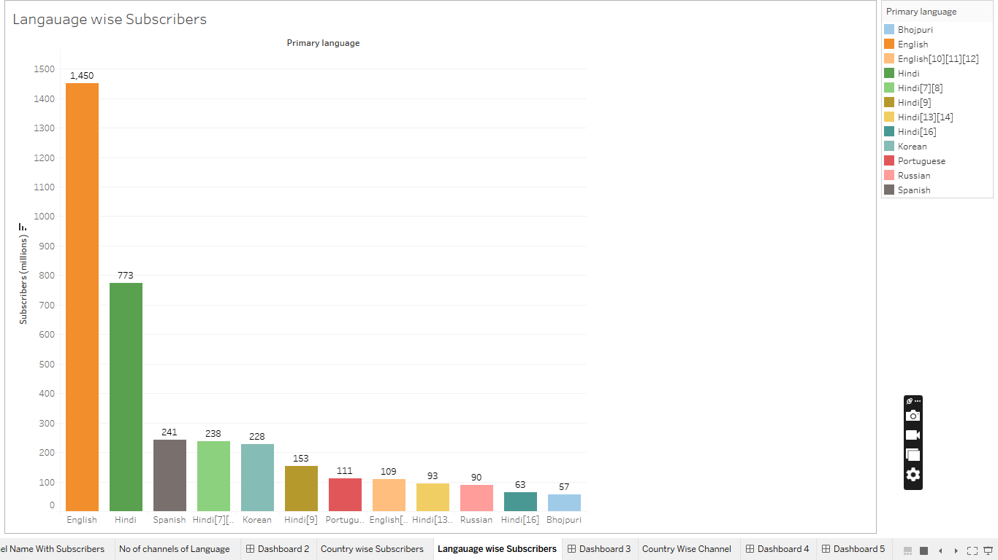

Dashboard 4

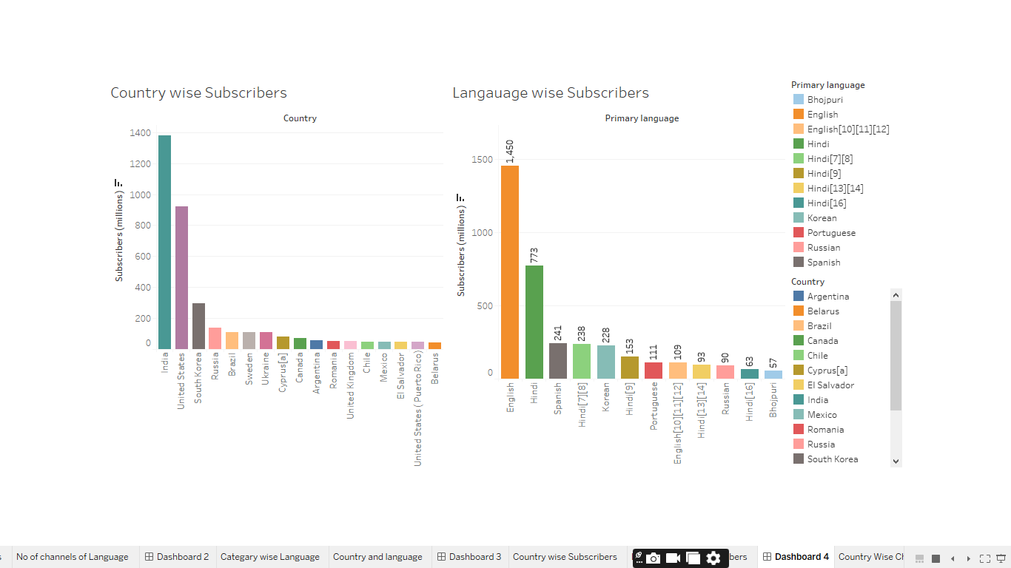

Country Wise Channel

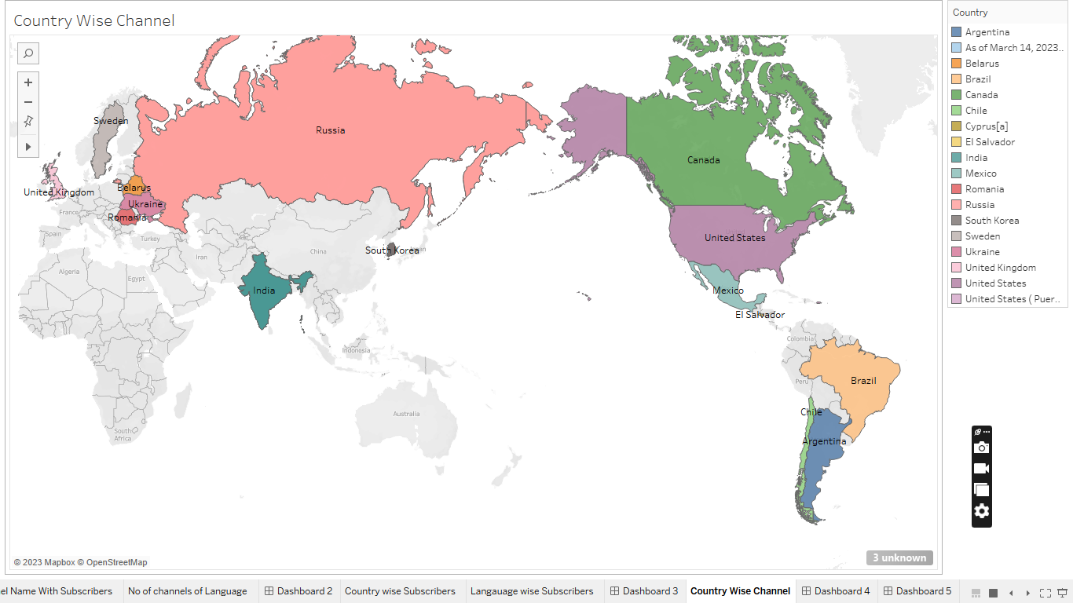

Dashboard 5

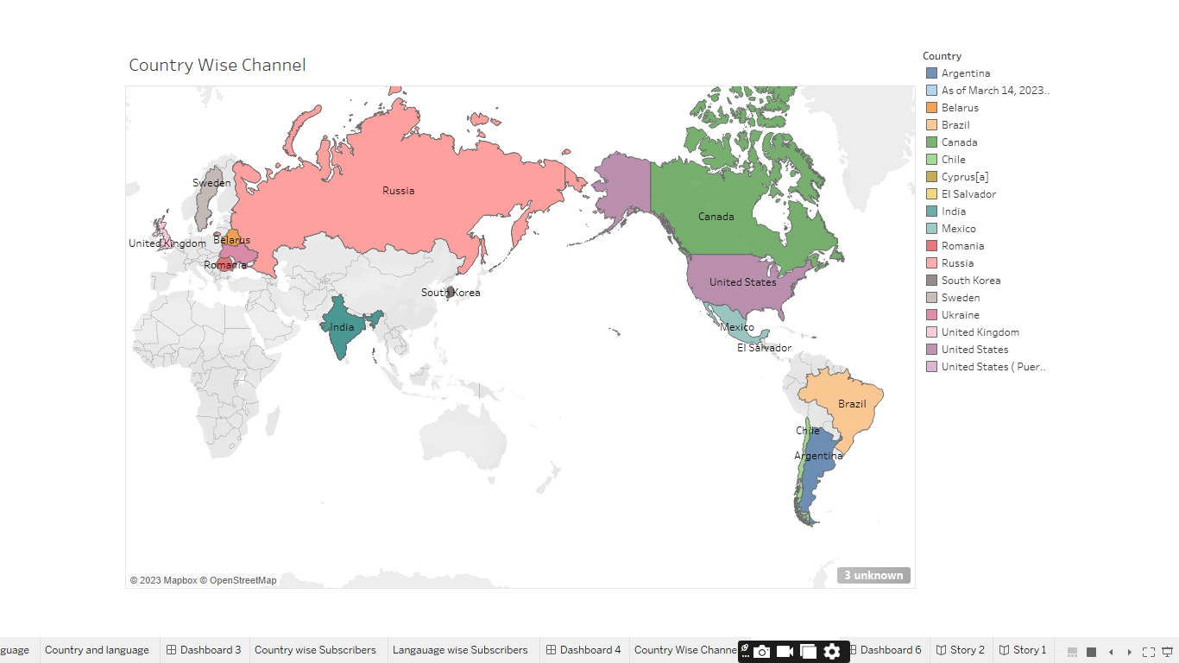

Dashboard

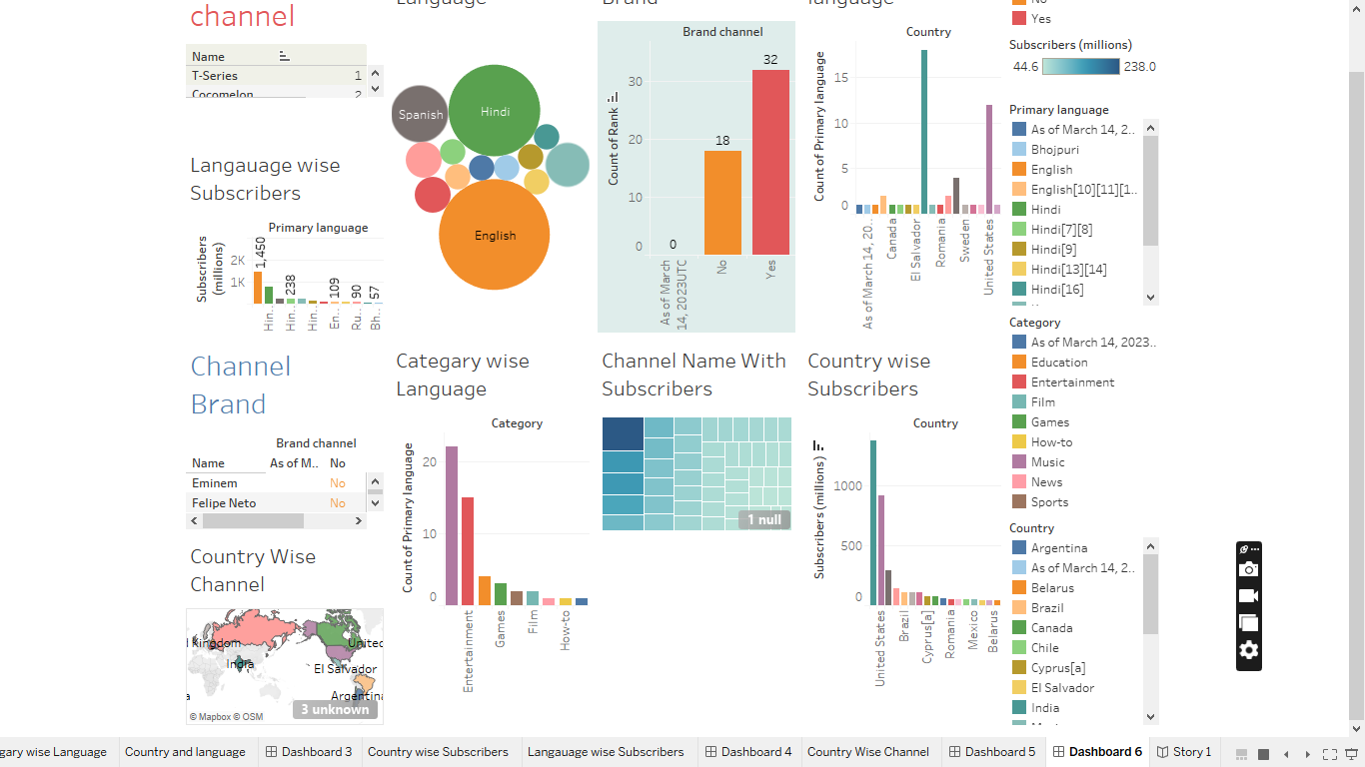

Story Board

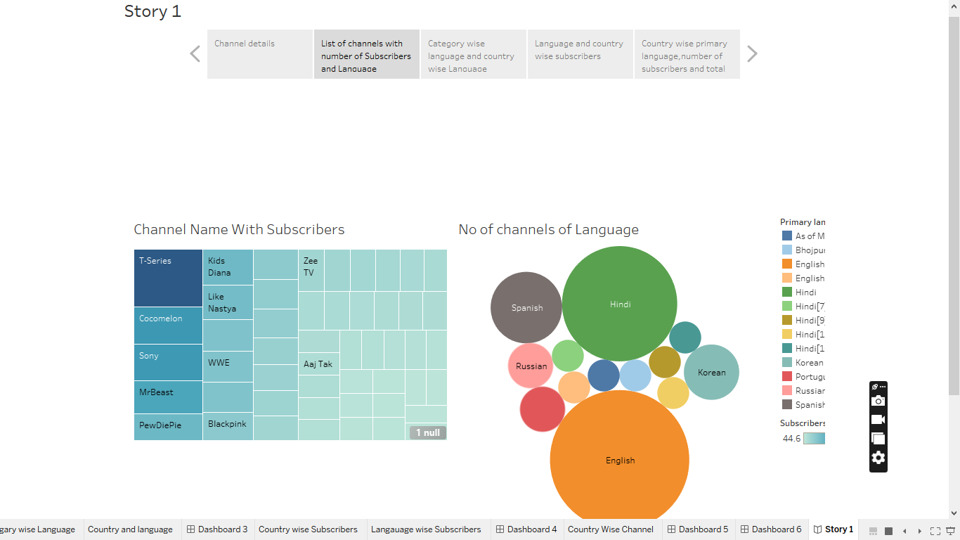

**4. Advantages and Disadvantages**

* It's free to use: You can watch and upload videos on YouTube. ...
* Wide selection of content: There is a wide variety of content available on YouTube, including music videos, educational videos, movie trailers, and more, as we have mentioned above.
* Ads- a drawback of YouTube for the audience.
* A lot of distraction ADVERTISEMENT.
* Obscenity- one of the biggest drawbacks that YouTube has. The kind of content that is uploaded on YouTube is largely in control today.
* Defamation and Bullying.
* Making money isn't that easy.

**5. Applications:**

* YouTube is a video sharing service where users can watch, like, share, and comment and upload their own videos.
* The YouTube app is available on many different devices, including mobile phones, smart TVs, and media streaming devices. Learn more about where to watch YouTube. You can download the YouTube app on Google Play. Visit the Google Play Help Centre to learn about managing Android app downloads from Google Play.

**6. Conclusion:**

We concluded that there are many attributes that cause a YouTube channel to become popular, which come with certain rules and patterns. For example, video topics, such as stories, animations, and interviews, proved to be quite unpopular, as none of the top channels had those topics as their most viewed videos. Using observations such as these, we made a decision tree to determine whether a YouTuber’s channel will become popular. We faced many limitation. First of all, there was a limited reliability of several websites in researching the topic, due to its influence largely remaining solely on the Internet. Also, we used a fairly small sample size, in comparison to the hundreds of other popular channels with several million subscribers that we could have also observed, which also somewhat reduces the reliability of our patterns and conclusions. In addition, another limitation faced was the fact that the data is unstable, as it is constantly changing. For instance, the number of subscribers and views a video gets is not a static variable. As time goes on, the number of subscribers will fluctuate, and the number of video views will increase. As there is still much left to explore with regard to the current topic, future research could contribute to our knowledge by developing theories that deepen our understanding of the factors that determine the characteristics of online social information. This could be done by expanding the present study through the investigation of social information on other online platforms. Although social information constitutes a major part of YouTube’s content, it also plays an important role on other social media, such as Facebook. A notable difference between YouTube and Facebook is that while on the first platform users are exposed to social information that is mainly created by strangers, on Facebook this social information is created mostly by acquaintances. Research indicates that this factor may alter how users respond to social information created by others. Hence, investigating social information on other platforms such as Facebook can broaden our insights into the factors on which online social information’s characteristics depend.

**7. Future scope**:

YouTube as a career is definitely rising as a current sensation. It does have a lot of scope, exposure and of course, leads you to popularity and fame in your field of choice. The present study contributed to our knowledge by exploring to what social information YouTube users are exposed and how this depends on the type of video that they watch. This way, it contributed to a broader understanding of how social information is created and what consequences this may have for the video views, (dis)likes, and comments seen by online video viewers. For researchers studying social media, it is important to know that much can be gained by looking beyond the content that is provided by social media platforms—knowledge about the total content to which social media users are exposed can be gained by examining platforms’ social information.